
ZM COUGAR WRESTLING CLOTHING ORDER 2014-2015

- T-Shirt Gildan 50/50 Carolina Blue $15
 | Youth XS | YouthS | Youth L | Adult  S | Adult  M | Adult  L | Adult  XL | Adult  XXL** | Adult  3XL** | Adult  4XL** | Adult  5XL** | TOTAL
Quantity
Total
Price

- Short-sleeve Performance Shirt Augusta 100% Polyester Columbia Blue $15
 | Youth  S | Youth M | Youth L | Adult  S | Adult  M | Adult  L | Adult  XL | Adult  XXL** | Adult  3XL** | Adult  4XL** | TOTAL
Quantity
Total
Price

- ¼ Zip Performance Pullover Champion 100% Polyester Navy w/ Stone $35
 | Adult  S | Adult  M | Adult  L | Adult  XL | Adult  XXL** | TOTAL
Quantity
Total
Price

- Sport Lace Hooded Sweatshirt JAmerica 80/20 Charcoal $40
 | Adult  XS | Adult  S | Adult  M | Adult  L | Adult  XL | Adult  XXL** | Adult  3XL** | TOTAL
Quantity
Total
Price

- Women’s Full-Zip Hooded Fleece Sweatshirt JAmerica 55/45 Dark Smoke $40
 | Adult  XS | Adult  S | Adult  M | Adult  L | Adult  XL | Adult  XXL** | TOTAL
Quantity
Total
Price

- Women’s Slouchy Pullover LAT 60/40 Smoke $20
 | Adult  S | Adult  M | Adult  L | Adult  XL | Adult  XXL** | TOTAL
Quantity
Total
Price
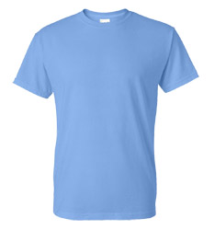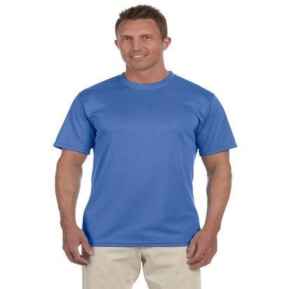 (sample design)
1 2
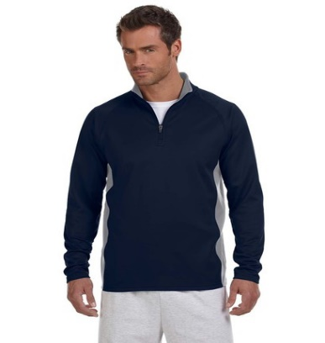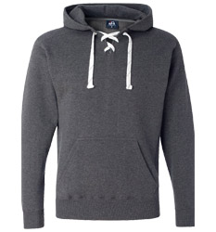
3 4
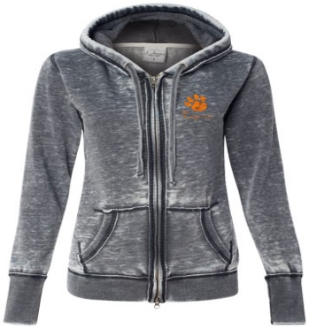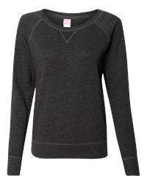
5 6

Make checks payable to: ZM Wrestling
**Add $2.00 for 2XL,3XL and 4XL**
Questions? Call/text Jen @ 507-358-1630…sample clothing is available to try on
Return forms & payment to Link Steffen (basket in wrestling room or drop off @ our house) by DECEMBER 1st

Name __________________________________ Grand Total $___________

